Heart Attack!

*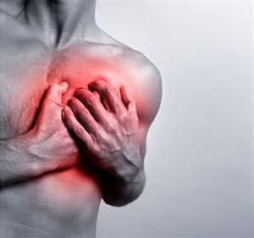*

*“A quick look into what a heart attack is and why it happens”*

Heart Attack: The Basics

What is it?

A myocardial infarction, more commonly referred to as a heart attack, is a result of some form of permanent damage to the heart muscle. When the heart is deprived of oxygen rich blood, the tissue dies and a heart attack occurs.

Why does it happen?

Plaque builds up on the walls of your arteries, narrowing the space for blood flow. The plaque then tends to rupture causing a blood clot, sometimes cutting off blood flow entirely. When blood flow is cut off from the heart, the muscle can’t get oxygen and the tissue dies.

What are the symptoms?

Symptoms of a heart attack that one typically experiences include chest pain or discomfort. This discomfort may spread to the arms, shoulders, back, neck, jaw or teeth. Shortness of breath, lightheadedness, and nausea also are common. Women, in particular, may not experience the chest pain that is commonly associated with heart attacks. Women tend to suffer from abdominal pain or “heartburn” and unusual fatigue.

<div class="masterPagestyle">

<h2>Heart Attack: The Basics</h2>

<em>A quick look into what a heart attack is and why it happens</em>

<h4>What is it?</h4>

<p>A myocardial infarction, more commonly referred to as a heart attack, is a result of some form of permanent damage to the heart muscle. When the heart is deprived of oxygen rich blood, the tissue dies and a heart attack occurs.</p>

<h4>Why does it happen?</h4>

<p>Plaque builds up on the walls of your arteries, narrowing the space for blood flow. The plaque then tends to rupture causing a blood clot, sometimes cutting off blood flow entirely. When blood flow is cut off from the heart, the muscle can’t get oxygen and the tissue dies.</p>

<h4>What are the symptoms?</h4>

<p>Symptoms of a heart attack that one typically experiences include chest pain or discomfort. This discomfort may spread to the arms, shoulders, back, neck, jaw or teeth. Shortness of breath, lightheadedness, and nausea also are common. Women, in particular, may not experience the chest pain that is commonly associated with heart attacks. Women tend to suffer from abdominal pain or “heartburn” and unusual fatigue.</p>

</div>